MINI PROJECT

Student Name: Aditya Pratap Singh
Brach :BCA
Semister:5th
Subject : Advance Social Media Analytics
UID: 23BCA10287
Section:BCA-8(B)
Subjnect - Code:23CAH-303

Hotel & Accommodation Review, comparing three types of accommodations across different regions in India:

🏨 Hotel & Accommodation Review
Exploring India's Stays – Heritage Hotels in Rajasthan, Beach Resorts in Goa, & Homestays in Himachal Pradesh
India’s travel scene is as diverse as its culture. From regal palaces turned into hotels to cozy mountain cottages and tropical seaside escapes, every region offers a unique flavor of hospitality. In this blog, we explore three distinct styles of accommodation: Heritage Hotels in Rajasthan, Beach Resorts in Goa, and Homestays in Himachal Pradesh.
Whether you’re a solo backpacker, a honeymooning couple, or a family seeking adventure, this guide will help you decide your ideal stay.

🧳 Accommodation Comparison Table
Feature | Heritage Hotels (Rajasthan) | Beach Resorts (Goa) | Homestays (Himachal Pradesh)
Average Cost/Night | ₹5,000 – ₹25,000+ | ₹4,000 – ₹15,000 | ₹1,000 – ₹5,000
Common Amenities | Royal suites, pools, spa, guided tours, traditional cuisine | Beach access, water sports, pool, bars, live music | Cozy rooms, home-cooked meals, local tours, mountain views
Unique Features | Historic architecture, regal ambiance, cultural performances | Ocean views, tropical vibe, party scene | Authentic local life, peaceful environment, nature hikes
Target Audience | Culture lovers, luxury travelers, history buffs | Young crowds, beach lovers, party-goers | Nature lovers, budget travelers, solitude seekers
Best Time to Visit | October – March | November – February | March – June, September – November
Cultural Experience | High – heritage walks, folk shows | Medium – beach shacks, music fests | High – live with locals, traditional food
Accessibility | Major cities like Jaipur, Udaipur, Jodhpur | Well connected by road & air | Accessible but might need local transport
Food | Rajasthani thali, royal cuisine | Seafood, Goa curries, continental | Himachali dham , momos, local dishes

🏆 Recommendations by Traveler Type
👪 Family Travelers:
- Best Option: Heritage Hotels in Rajasthan
- Why? Safe, spacious, and full of cultural learning experiences. Kids can enjoy elephant rides, puppet shows, and historic forts.
💑 Couples/Honeymooners:
- Best Option: Beach Resorts in Goa
- Why? Sunsets by the beach, candlelight dinners, and private villas make for a romantic getaway.
🧭 Solo Travelers:
- Best Option: Homestays in Himachal Pradesh
- Why? Budget-friendly, safe, and a great way to connect with locals and fellow travelers.
🎒 Adventure Seekers:
- Best Option: Homestays in Himachal Pradesh
- Why? Perfect base for trekking, paragliding, river rafting, and exploring Himalayan trails.
🎉 Party Enthusiasts:
- Best Option: Beach Resorts in Goa
- Why? Beach parties, nightclubs, and music festivals are all within reach.

📸 Visual Glimpse
I'll now generate suitable images for each accommodation style to enhance the blog visually.
1. Heritage Hotel in Rajasthan
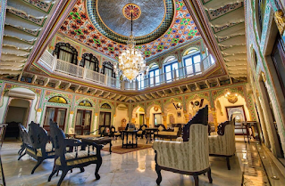


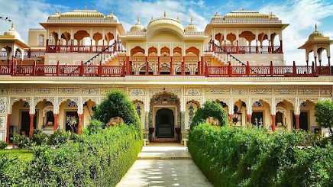

2. Beach Resort in Goa
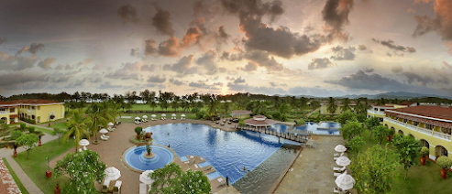


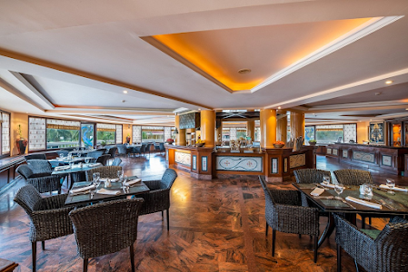

3. Homestay in Himachal Pradesh
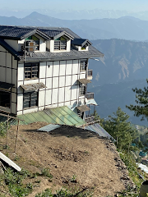

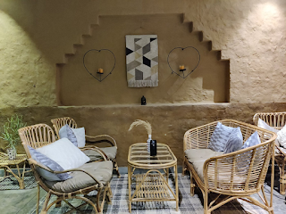

By Aditya Pratap Singh

